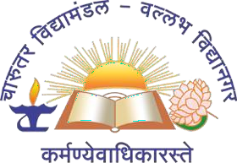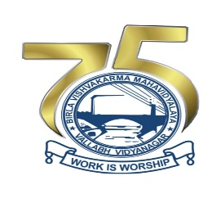

ADVANCED SOLID MODELLING USING SOLIDWORKS

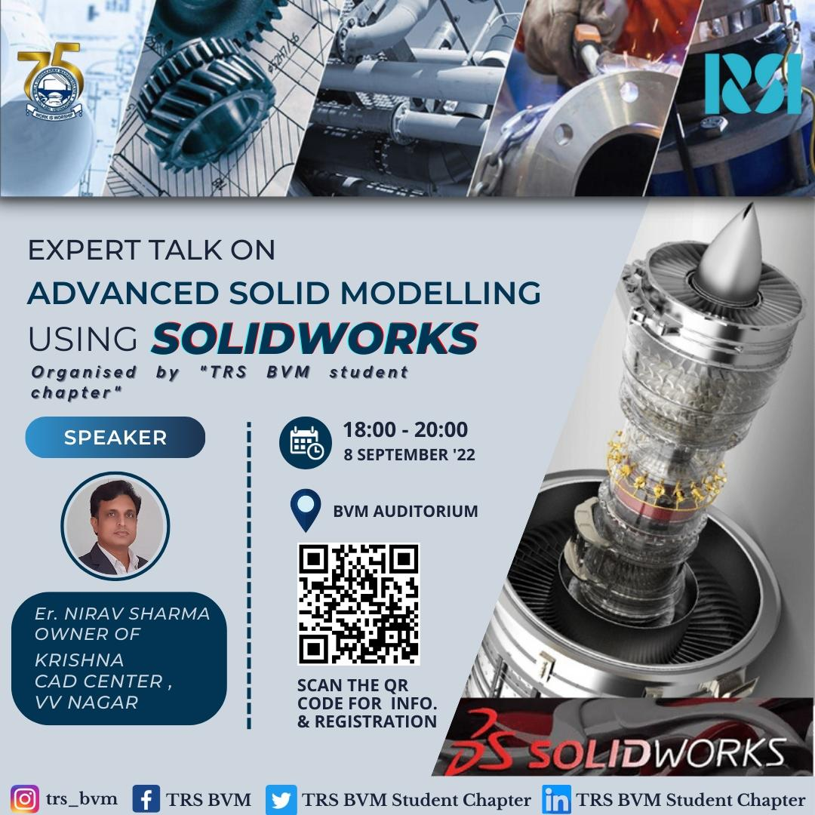

BVM ENGINEERING COLLEGE
Title of the event/workshop | Advanced Solid Modelling Using SOLIDWORKS
Name and Designation of the Experts: | Name |  |  | Designation
Name and Designation of the Experts: | Mr. Nirav Sharma |  |  | Technical Managing Director
Contact Information of the Experts | Sr. No | Name |  | Email ID
Contact Information of the Experts | 1 | Mr. Nirav Sharma |  | Krishnacadcenter@gmail.com
Name of the Institute | Birla Vishvakarma Mahavidyalaya Engineering College
Name of the Principal of the Institute: | Dr. Indrajit N. Patel
Year/Semester of the Students: | Under Graduate Students[2ndyear/3rd year]
Professional body  under which event organized: | TRS BVM Student Chapter
Date and Time of the Event/Workshop: | Date: 8th September 2022, Thursday Time: 6:00PM to 8:00PM
Venue Name | D101
No. of Days for Event/Workshop | 01
TRS BVM  Counsellor’s Details: | Name: Prof. Jayesh Koisha & Prof. Alpesh Damor
Coordinator’s Details: | Sr.no | Name | Email ID
Coordinator’s Details: | 1  2 | Jay Rathod  Rayyan Mansuri | 20me020@bvmengineering.ac.in  20me039@bvmengineering.ac.in
Total No. of Students: | 100+

SUMMERY TABLE

\ 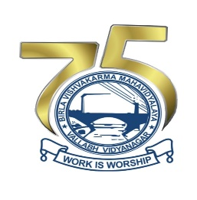

Objective of the Event:

- The purpose of the event was to give detail introduction about solid modelling using solidworks and breif idea about CAS, CAM and CAE.

- The session also focused on to make 3d models easily and accurately using solid works.

Expected Outcome

- Participants were able to understand about the significance and various features of solidworks.

- Participants get brief knowledge about CAD, CAM, CAE and information about useful tools to make 3d models.

About the Speaker

- Mr. Nirav Sharma, 7 Years’ experience in Different Industries, 1 Year apprentice at Elecon Eng. (1) Ltd., 2 Years at Tech Roll Industries, Odhav Ahmedabad as Production cum QC Engineer. He is the Managing Director (Technical) Krishna CAD Center, Director - Krishna Infotech, 3 Years in Real Strips Ltd. Bavla - Ahmedavad as Designer -Project Engineer, 1 Year at Shah Folis Ltd Shantej-Ahmedabad as Designer-Project Engineer Years’ Experience in Training and Consulting of CAD CAM CAE at Krishna CAD Center and Krishna Infotech.
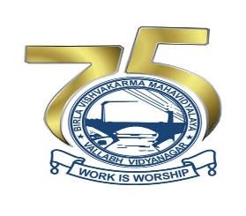

About The Event

- On 8th September, 2022 an expert talk was organized by TRSBVM Students Chapter. Expert talk was on topic of advanced solid modelling using solidworks from 6:00 pm to 8:00 pm.

- Our expert, Mr. Nirav Sharma, the Technical Managing Director and Autodesk Authorized Certified Instructor at Krishna CAD Centre and Mr. Jaimin, the centre head of Krishna CAD Centre.

- The Inauguration ceremony was conducted by HOD Mechanical Department Dr. P.M George, Dr.Vinay Patel, Prof.Jayesh Koisha, and Prof. Alpesh Damor.

- The session was initiated by Mr. Nirav Sharma on detail introduction on CAD , CAM and CAE , knowledge of Design Softwares like AUTOCAD, SOLIDWORKS, Fusion 360 AND Creo(PRO-E) , Comprehensive knowledge of Manufacturing Processes and Supply Chain principles of mechanical engineering , knowledge of general Machining Techniques and various manufacturing processes and comprehensive knowledge of Product Lifecycle Management and computer-aided engineering.

- Further the session was hand over to Mr. Jaimin, the head of KRISHNA CAD CENTRE. He gave the detailed information on solid modelling using solid works which includes 2d drawing and sketches , how to make Drawing sheet in solidworks , 3d modelling , assembly and rendering of parts , analysis and simulation of model .

- Further, he showed interesting features in solidworks to make compact and complicated design. Also, they presented few eye catching projects made by their students .At last a question & answer session was carried out.

- At last the vote of thanks was given by Prof. Alpesh Damor to our experts.

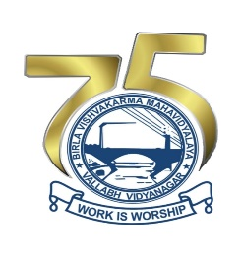

Glimpses of the Event

